ASSUMPTION PATHWAY SCHOOL
RAMS FORM
Bowling
Part A: Details of CCA/Activity (to be completed BEFORE activity) |  |  |  |  |  |  |  |  | Vetting Officer |  |  |  | Approving Officer
RAMS Team  Leader: |  |  |  | Member(s): |  |  |  |  | Vetted By: |  |  |  | Approved By:  (Chief Safety Officer)
Name of CCA/Class (if applicable): | West Area Scouts |  |  | Name of Activity: |  |  | West area Bowling |  | Designation:  (VP/HOD) |  |  |  | Designation:
Date & Time of Activity: | 2 April 2016 |  |  | Venue of Activity: |  |  | Westwood Bowl, Civil Service Club @Bukit Batok, 91 Bt. Batok West Ave 2 S659206 |  | Signature: |  |  |  | Signature:
Name of Vendor/Instructor (If applicable): |  |  |  | Contact No. of Vendor/Instructor (If applicable): |  |  |  |  | Date: |  |  |  | Date:
Vendor/Instructor’s Address (If applicable): |  |  |  |  |  |  |  |  | Remark: |  |  |  | Remark:
Signature of RAMS Team Leader: |  |  | Date of Assessment:
Part B: Programme Details (to be completed BEFORE activity)
(Fill in below or attach document as Annex)
Description of Event |  |  |  |  | Learning Objectives |  |  |  |  |  |  |  |  | No. of Participant
WEST AREA SCOUT BOWLING CHALLENGE 2016 |  |  |  |  | - Fun, Interaction with Scout Units  - Build Team Spirit within the Area
Part C: Assessment Review
(Assessment Review must be completed after each activity/cycle)
Last Review Date: |  |  |  |  |  |  |  |  | Next Review Date:
Assessment Review Comment:
Name of Officer-in-charge: |  |  |  |  |  | Signature: |  |  |  |  |  | Date:
Vetted/approved by:  (VP/HOD) |  |  |  |  |  | Signature: |  |  |  |  |  | Date:

Hazard Identification |  |  |  | Risk Evaluation |  |  | Implementation
No. | Description of Activities/ Work Processes | Hazard | Possible Accident /  Ill Health | Severity | Likelihood | Risk Level | Risk Control | Action Officer, Designation  (Follow-up date) | Remarks
1 | Medical | -Pre-existing medical conditions  -Falling ill | -Injuries  -Illnesses  -Accidents (bowling ball hitting the feet) | 3 | 2 | 6 | -Maintain a list of participants’ particulars, family contacts and medical conditions.  -Remind participants to bring along medicine prescribed by doctors for pre-existing medical conditions. Ask the students to pack them in transparent ziploc bags and label their medication clearly (with names, NOK details and prescription etc).  -Standby a certified First-aider among the adult supervisors.  -Be familiar with the locations of the phones and the contact numbers of ambulances and nearby clinics/ hospitals.  (Please refer to the last 2 pages) | Teachers/  Leaders
2 | Transportation | Road Accident | Bus drivers not familiar with route  Bus drivers are careless | 3 | 2 | 6 | Participating schools will cater buses from only reliable companies.  Scouts who are travelling to the venue on their own are reminded by teachers and leaders to take caution when taking public transportation. | Teachers/ Leaders
3 | Venue | Heat related matters | Air conditioning not working in the venue | 2 | 2 | 4 | Scouts will be moved out of the venue and into the open space.  Evacuation plans in the venue display where is the assembly ground and direct scouts to the area.

CHAPTER

(RAMS)

2

RISK ASSESSMENT

Introduction

- The Workplace Safety and Health (Risk Management) Regulations 2006 requires all workplaces, including schools, to conduct risk management for school activities/work processes.

- The Risk Assessment Management System (RAMS) provides schools with a useful tool to systematically identify possible hazards of an activity/work process and take reasonably practicable measures to eliminate or reduce the potential risks to an acceptable level.

General Requirements

- RAMS should be conducted by a team of people, including external service providers if applicable, who collectively have adequate knowledge of the nature of activity/work processes.

- A RAMS Register that records the documented RAMS is maintained and reviewed by designated persons.

- RAMS is reviewed once in three years minimally, or when there are:

  - Accidents, near misses or dangerous occurrences as a result of exposure to a hazard;
  - Significant change(s) in process, facilities, work practices or procedures or change in workplace condition and site layout; or
  - New information on WSH risks is made known.

- RAMS documents are to be kept for at least three years from the RAMS approval date.

- Risk control measures or safe work procedures (SWP) are monitored for their effectiveness.

- All persons exposed to the risks identified in RAMS are to adhere to the measures stipulated in RAMS.

- The templates for the RAMS and RAMS Register are shown in Annex A and B respectively. Generic RAMS for school operations such as building and environment within school, road safety, overseas learning journeys and PE/CCA are provided in School Safety Website at http://intranet.moe.gov.sg/schoolsafety for school’s customisation.

.
5-step Management Process of RAMS

- Prior to conducting a RAMS, reference should be made to the existing guidelines (e.g. in School Safety Handbook) and existing school safety policies for the activity/work processes.

- Schools may streamline the scope of RAMS by appropriate categories for school activities/work processes to facilitate the conduct of RAMS to be as practical as possible. Some examples of categorization are as follows:

  - PE
  - CCA
  - Overseas learning journeys
  - Local learning journeys
  - Camps
  - Science laboratories
  - Nutrition and food rooms
  - Design and technologies studios
  - Art rooms
  - Building and environment within school
  - Road safety

- Step1: Hazard Identification

  - The process begins with identifying hazards that may cause injury to personnel, damage to equipment or structures, loss of material, or reduction of ability to perform a prescribed function.

  - The ‘W’ checklist in Annex C provides useful considerations to help the RAMS team identify possible hazards associated with a specific activity/work processes.

- Step 2: Risk Evaluation

a. The next step is to evaluate the potential impact of a hazard on the activity. The risk can be evaluated by its potential severity of the injury caused by the hazard and the likelihood of incident occurrence.

  - Determining the potential severity of the injury:

    - Severity is the degree or extent of injury or harm caused by accidents/incidents arising from identified hazards. Severity is classified into 5 categories: Insignificant, Minor, Moderate, Major and Catastrophic (Table 1).

Table 1: Severity of injury, risk score and description

Severity | Risk Score | Description
Insignificant | 1 | No injury, incur low financial loss, low environmental impact
Minor | 2 | Injury requiring first aid treatment, incur some financial loss/ some environmental impact
Moderate | 3 | Injury requiring medical treatment or ill-health leading to disability (e.g. lacerations, burns, stains, minor fractures, dermatitis, deafness, work-related upper limb disorders), incur high financial loss, high environmental impact
Major | 4 | Serious/extensive injury (e.g. amputations, major fractures, multiple injuries, acute poisoning and fatal diseases), incur major financial loss, severe environmental damage
Catastrophic | 5 | May result in death or large number of serious injuries, incur huge financial loss, environmental disaster

    - As the severity of the injuries (e.g. lacerations, fractures, or fatal injury) refers to the intrinsic or inherent nature of the adverse effect that may result from the hazard, it does not depend on the controls in place. Therefore, the existing controls should not be taken into account when assigning the severity level.

  - Determining the likelihood of the occurrence of incident(s):

    - Likelihood of occurrence of an accident and/or incident is also classified into 5 categories: Unlikely, Seldom, Occasional, Likely and Frequent (Table 2).

Table 2: Likelihood of occurrence, risk score and description

Likelihood | Risk Score | Description
Unlikely | 1 | Unlikely to occur
Seldom | 2 | Not likely to occur but possible
Occasional | 3 | May occur occasionally
Likely | 4 | Quite likely to occur
Frequent | 5 | Expected to occur frequently

    - To minimise the subjectivity of estimating likelihood, the following sources of information should be considered in addition to looking at existing controls:

- Past incident and accident records
- Industry practice and experience

  - The risk may then be assessed with the use of the 5 x 5 risk matrix (Table 3). The risk level is determined by the multiplication of the risk scores for severity and likelihood.

Table 3: Risk matrix to determine risk level

Severity  Likelihood | Catastrophic  (5) | Major  (4) | Moderate (3) | Minor  (2) | Insignificant  (1)
Frequent  (5) | 25  High | 20  High | 15  High | 10  Medium | 5  Medium
Likely  (4) | 20  High | 16  High | 12  Medium | 8  Medium | 4  Medium
Occasional  (3) | 15  High | 12  Medium | 9  Medium | 6  Medium | 3  Low
Seldom  (2) | 10  Medium | 8  Medium | 6  Medium | 4  Medium | 2  Low
Unlikely  (1) | 5  Medium | 4  Medium | 3  Low | 2  Low | 1  Low

- Step 3: Risk Control Options and Decisions

  - Based on the risk level determined in Step 2 (Risk Matrix), risk controls should be developed to eliminate/reduce the risk level to an acceptable level. This can be done by reducing the Severity and/or Likelihood.

  - When the risk level is Medium/High, effective and practicable risk controls must be implemented to reduce them to an acceptable level.

  - Table 4 shows the acceptability of risk and recommended actions for different risk levels to guide the selection of risk controls.

Table 4: Risk score, risk level, risk acceptability and recommended actions
Risk Score | Risk Level | Risk Acceptability | Recommended actions
15 – 25 | High Risk | Not acceptable | - Immediate action required. Terminate the activity if additional control measures do not lower the Risk Level. High Risk level must be reduced to at least Medium Risk before activity commences.  - Risk control measures should not be interim and should not be overly dependent on personal protective equipment or appliances. If need be, the hazard should be eliminated before activity commences.  - Immediate management intervention is required before activity commences.
4 – 14 | Medium | Tolerable | - A careful evaluation of the hazards should be carried out to ensure that the risk level is reduced to as low as is practicable within a defined time period.  - Interim risk control measures, such as administrative controls, may be implemented.  - Management attention is required.
1-3 | Low Risk | Acceptable | - No additional risk control measures may be needed. However, frequent review may be needed to ensure that the risk level assigned is accurate and does not increase over time.

- Step 4: Implementation of Control Measures

Upon selection of Risk Control measures, appointed action officers should follow-up with the implementation/actions within a specified timeline. This ensures timely implementation and clearer supervision.

- Step 5: Effective Supervision

  - The final step ensures the effectiveness of risk controls. The action officers are responsible for enforcing the control measures and will have to be vigilant at all times.

  - After implementing the control measures, there is a need to analyse, evaluate and decide whether the risk level has been lowered to an acceptable level.

Communication

- Throughout the RAMS, the following communication to stakeholders is essential:

a. Engage and involve people to contribute to the risk management process;

b. Provide clarity on the risks, processes, control measures, perceptions etc;

c. Help stakeholders make informed decisions; and

d. Enable stakeholders to know the risks they face and the appropriate control measures to implement to reduce and/or manage the risks.

Nearest 24hr clinic:
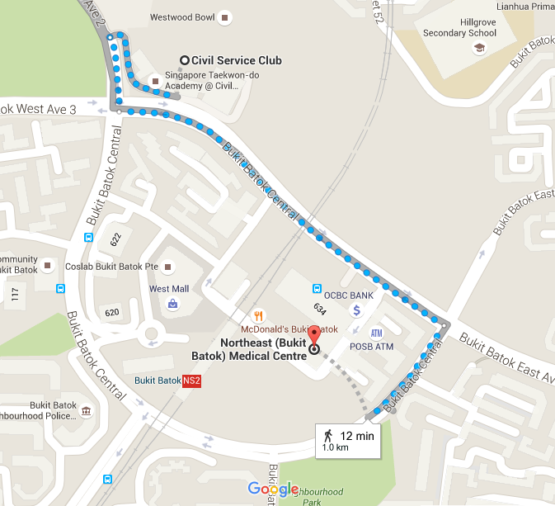

Nearest Hospital:
